# Assignment 35 Part II

**Exercise 1.2** The most important difference between generic software and custom software is that, in generic products, the organization that develops the software controls the software specification. For custom products, the specification is usually developed and controlled by the organization that is buying the software.

**Exercise 1.3** The four most important attributes that all professional software should have are:

* Maintainability
* Dependability and security
* Efficiency
* Acceptability

Furthermore we find it important that the program is easy to use and intuitive.

- Responsiveness  
- Data security  
- Extendibility  
- Accessibility

**Exercise 1.8** We have discussed this topic briefly and thought about how such a set of rules could look like and we have found it very hard to define. Furthermore we think the project manager has the final responsibility. As a developer one should notify ones project manager and as it is his final responsibility.  
A certificate might not be a bad idea for project managers.

**Exercise 2.1**    
ABS: Waterfall model  
Reliability is a main factor and it is not possible to release the software in minor parts.

A virtual reality system to support software maintenance: Incremental model.  
There are many factors to account for and it would be difficult to specify the entire system at once.

A university accounting system that replaces an existing system: Reuse-oriented software engineering.  
Reusing parts of the existing system might save time and money. There is a lot of accounting systems available.

An interactive travel planning system that helps users plan journeys with the lowest environmental impact: Incremental model.  
There are many factors to account for. Adding additional modules over time would be practical.

**Exercise 2.5**The main activities in software design process and their outputs are:

Software specification: Define functionality of the software and constraints on its operations.

Software design: Code the program and meet the specifications.

Software validation: Ensure that the software does what the customer wants.

Software evolution: The software most evolve to meet changing customer needs.

**Exercise 2.9**Static view show us process activities.  
Dynamic view show us phases over time.

# Part III

**Use case**A customer selects are rental duration and a vehicle type. If there is a vehicle of that type at that time available, the customer can reserve it.

**Domain model**

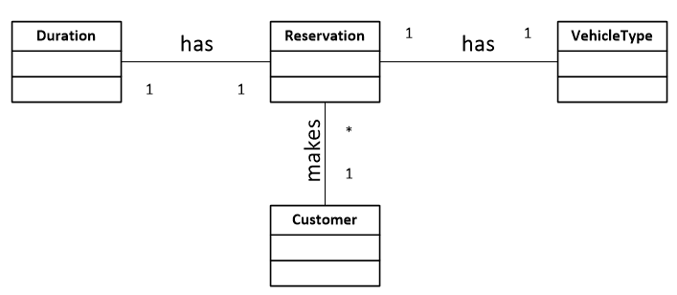

**ER-diagram**  
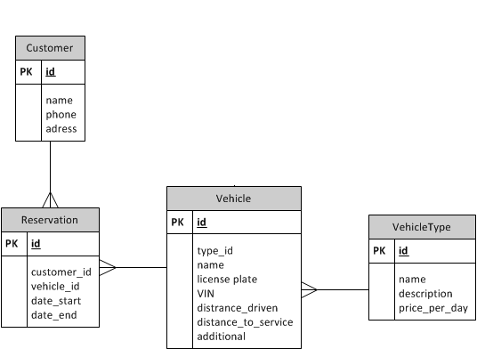

**Interaction diagram  
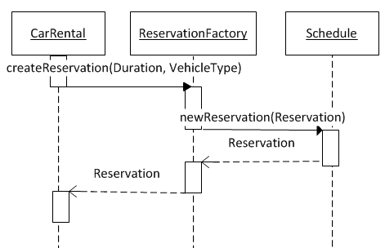**

**Class diagram**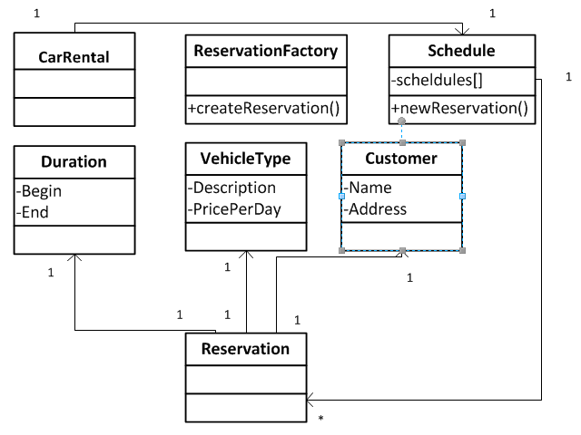

**Object-oriented information system**  
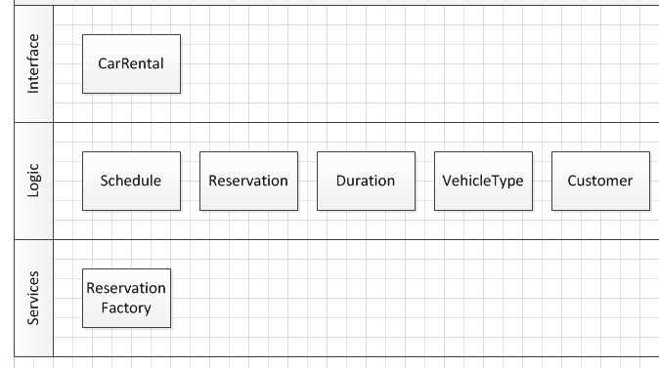

The only visible part of the program is the class “CarRental”.  
“ReservationFactory” performs a service with use of the logic classes.